**Summary of the interview**

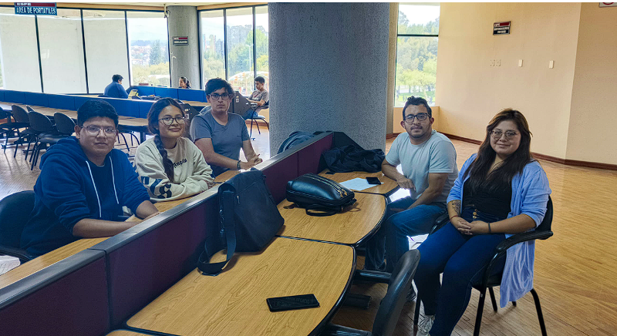

**Screenshots and customer feedback:**

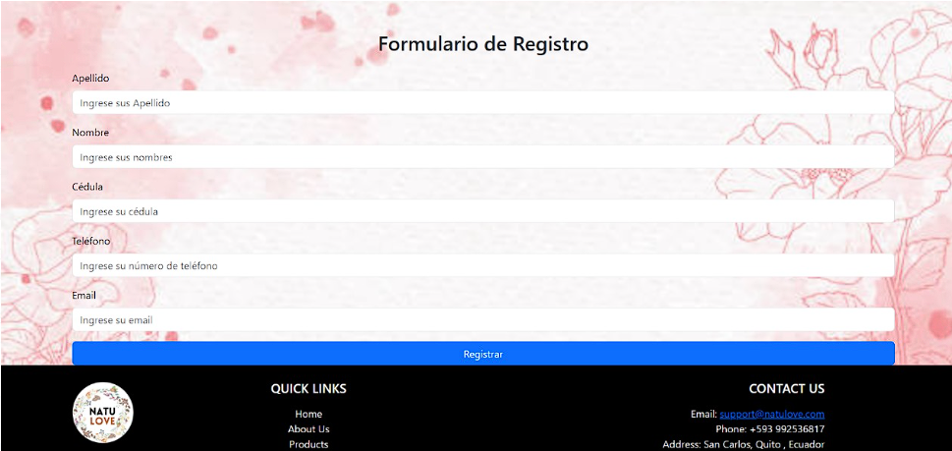

Although the floral background is beautiful, it doesn't have much connection to a chocolate store. You could use a design that evokes what you sell, such as a soft brown background or textures related to chocolate (cocoa, chocolate bars, etc.).

The form is well-organized, with aligned labels and inputs, making it easy to fill out.

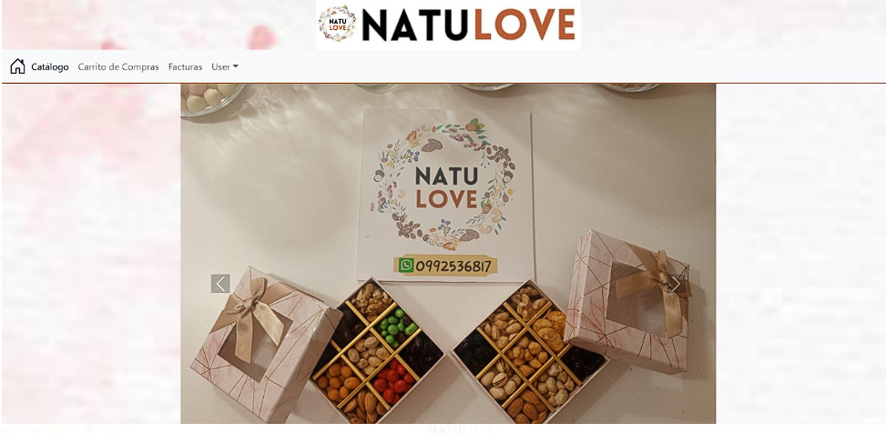

The main photo showcases your products attractively, with good lighting and a focus on the gift boxes that convey quality.

The menu seems somewhat simple and could have a more appealing design. For example, you could use buttons with rounded edges or icons next to the options to make it more visual.

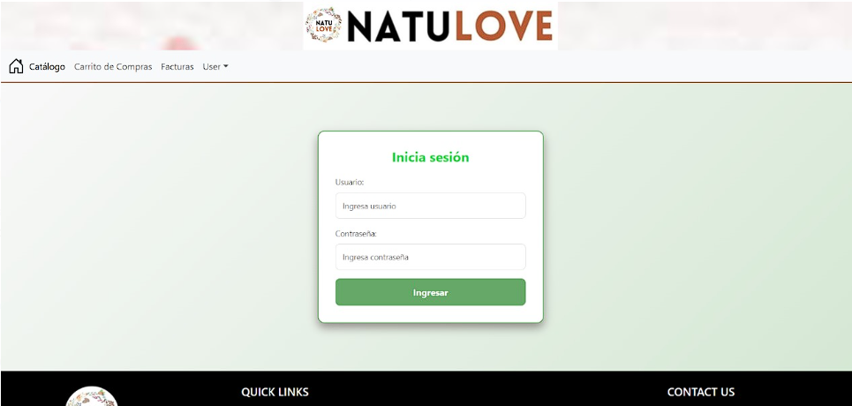

You can give the "Login" button text a more eye-catching style (for example, changing color on hover).

Add a small icon next to "Username" and "Password."

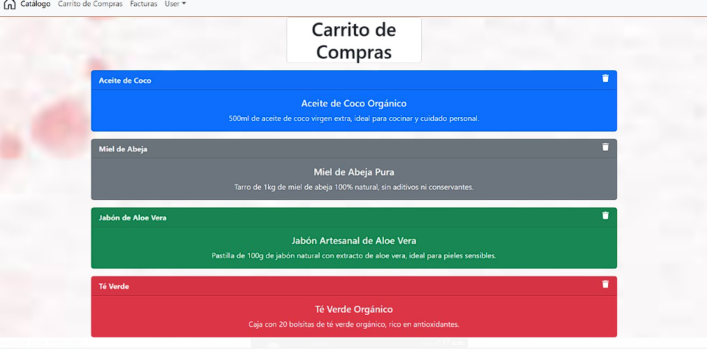

The current interface is functional but lacks a more appealing design that reflects the identity of a souvenir and chocolate shop. Visual elements such as product images, more eye-catching backgrounds, or more original fonts could be incorporated to create a more enjoyable shopping experience.

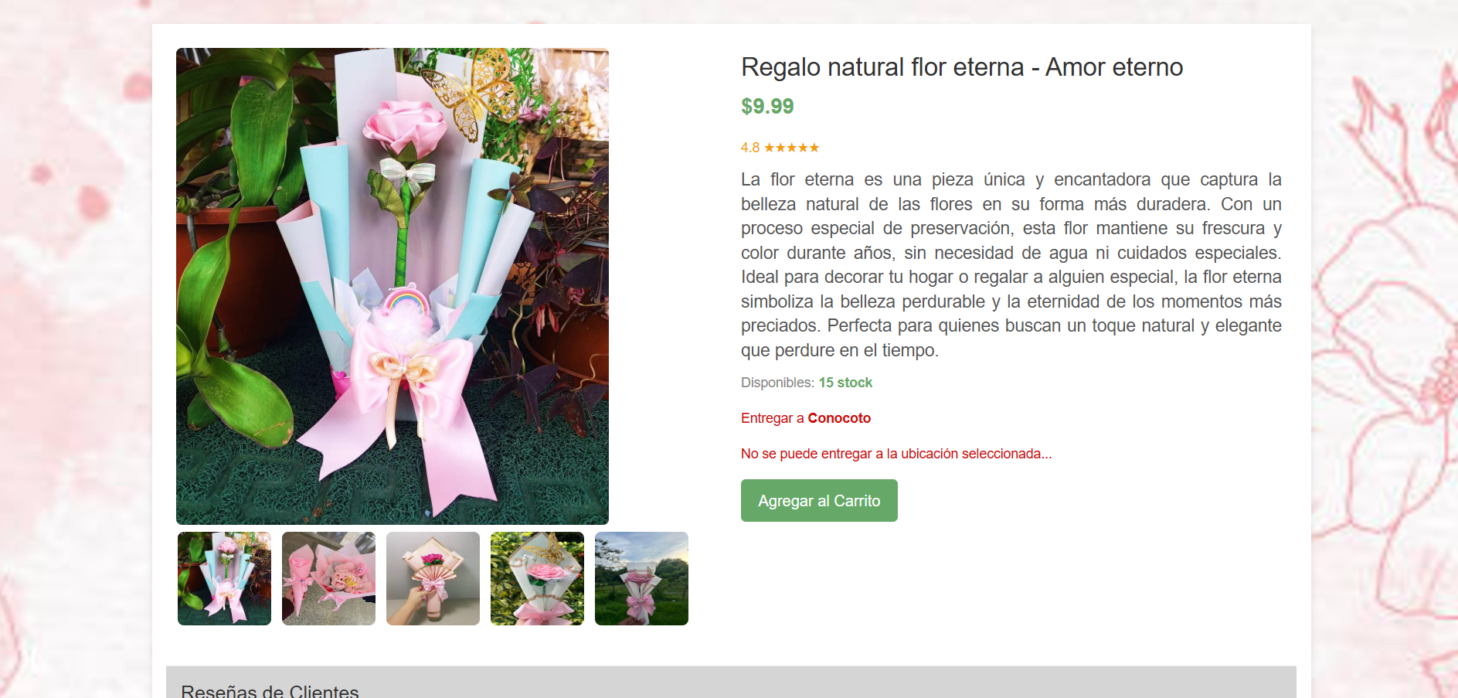

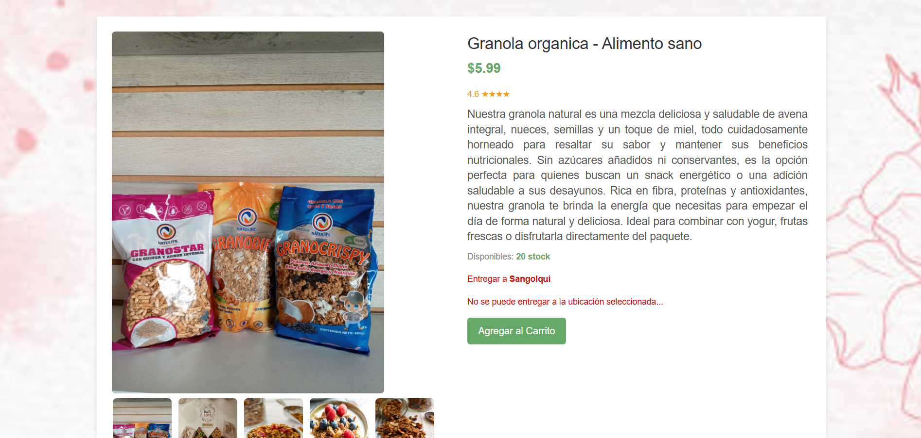

The screen's appearance is striking and includes everything necessary for the customer to view the essential product information and see it before purchasing. On the other hand, the comments are not helpful for improving our products. However, the floral background is not to the customer's liking, and we should replace it with a more representative image or pastel colors.